GRADUATION INTERNSHIP REPORT



Aggregated Data Management in a Digital Portfolio

|  |  |
| --- | --- |
| Data student: | |
| Full name: | Edita Pronckute |
| Student number: | 3907872 |
| Assignment period: | 06.02.2023 – 30.06.2023 |
| Data company: | |
| Name company/institution: | Drieam |
| Department: | Product & Development |
| Address: | Don Boscostraat 4, 5611 KW Eindhoven |
| Company tutor: | |
| Family name, initials: | Coline van Leeuwen |
| Position: | Software Developer |
| Signature: |  |
| University tutor: | |
| Full name: | Jo-An Kamp |
| Final report: | |
| Title: | Improving Usability of Portflow Evidence Section |
| Portfolio repository: | https://github.com/EditaAnomaly/S8-GI-Drieam/wiki |
| Date: | 06.04.2023 |

Foreword

This report is an overview of the Graduation Internship program of the Fontys University of Applied Sciences carried out at the Drieam ed-tech company. It is written using APA style format following the provided Internship Report Guidelines Template.

The aim of the internship was to improve the usability of a part of the Drieam’s product. The product is a digital portfolio called Portflow and the focus was on improving the aggregated data management within the portfolio for students.

During this internship I was a part of a development team working on improving and maintaining the Portflow. The team consisted of several full-stack developers with years of experience in the field. I was the member responsible for the research, design and the development of the My Evidence section of the product. It is the section that enables users to manage all their aggregated data (evidence). This paper is an overview of my efforts, mostly focused on the process and results of the completed work.

I have grown a lot during these last 5 months, both professionally and personally. The guidance received during this internship was greatly appreciated, the support from my tutor and mentors helped me face my challenges and become a better developer.

Contents

Summary 1

Glossary 2

Chapter 1: Introduction 3

Chapter 2: Assignment Overview 4

3.1 Opportunities 4

3.2. Goals 4

3.3. The Approach 5

Chapter 4: Process and Results 6

4.1 The Research 6

4.2 The Design 6

4.3 The Realization 7

Chapter 5: Conclusions and Recommendations 8

5.1 The Advice 8

5.2 The Management 8

Personal Reflection 9

References 10

Summary

This report describes the duration of the graduation internship at Drieam, an education technology company. It offers various software solutions that aid educators and students.

The assignment was to find a way to improve the usability of Portflow Evidence Section. The section responsible for managing all aggregated data and is only accessible to the owner of the portfolio. The work began in a team of 5-9 developers and design thinking was the chosen approach. First, I learnt more about the company, their culture and products. Second I looked into the competitors to gain insight into the existing products in the market. This helped to better understand the existing problem/ opportunity and start visualizing the potential solution that was later implemented.

The lead concept was created after several iterations of sketching and wireframing the potential solutions then reviewing them with the stakeholders. The final product is a reinvented evidence table that provides a better overview of all aggregated evidence as well as offers tools to manage it. The solution is a production ready code that should be deployed and available to the users as of the next study year.

The internship concluded with testing the solution with students that already are familiar with the product.

Glossary

|  |  |
| --- | --- |
| Notation | Description |
| EdTech | Academic preparation of students using digital means. |
| LMS | Learning Management System that offers administration, automation and tracking of educational courses, training programs and materials. |
| LTI | Learning Tools Interoperability is a series of edtech specifications for a standard that enables applications to be integrated with a LMS. |
| PR | Pull Request is an event where one developer asks another to review the code that they would like to merge into the project in the context of version control management system. |
| Tender | A formal process where businesses are bidding and competing for a contract that requires specific skills or services on an ongoing basis. |

# Chapter 1: Introduction

Drieam is an ed-tech company that was founded in 2014 by Gaston, Tim and Bart. While studying at the Eindhoven University of Technology, they had a shared vision of changing the way students interact digitally. Thus, the name of the company – three students with a shared dream. One of the first applications, they created was FeedPulse, that enabled educators and students to digitally share feedback as a central part of the learning process. It was very successful and is being actively used by Fontys students too.

Since then, the company has grown to over 50 employees building and maintaining many more applications. The Drieam has become the market leader in its field in the Benelux region and is even expanding overseas. Prestigious universities such as Yale, Cambridge and IMD use Drieam’s applications on a daily basis.

Portflow is another successful product of the company. It is a student-led development and assessment portfolio application. It was developed adhering to the Learning Tools Interoperability (LTI) standard, enabling easy integration with a Learning Management System (LMS). Therefore, it can be launched within the context of a LMS such as Canvas and Brightspace or used as a stand-alone application. The assignment is to help improve part of it.

More information about the assignment can be found in the following chapter. Chapter 2 explains the assignment in more detail by providing more context. Chapter 3 explains the process and describes the results. The conclusions and recommendations can be found in Chapter 4. Some of the supporting, process related files (i.e., sketches, wireframes, user requirements and other documents) are included in the Appendixes and can also be found in the [repository](https://github.com/EditaAnomaly/S8-GI-Drieam).

# Chapter 2: Assignment Overview

## 3.1 Opportunities

Portflow is used by thousands of students across the globe. It can be used for a project, subject or entire course. It allows students to gather and showcase the evidence of work done (documents, presentations, posters, images, URLs, demo recordings etc.) in a meaningful way. However, with every use of portfolio more and more evidence is aggregated that it may become challenging to keep track of. For this purpose, there is a “My Evidence” section in each portfolio where the owner can overview and manage all of their files.

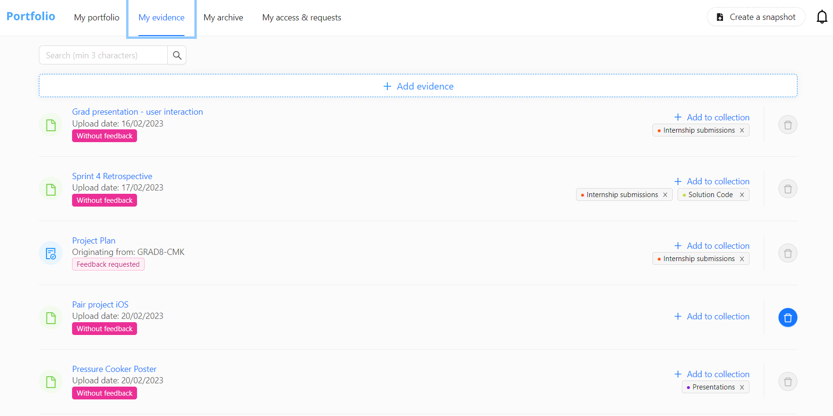

Image 1. Example of current My Evidence Section of Portflow.

My Evidence offers a rather simple list at the moment to help overview the aggregated data and does not offer many features to manage the contents. It is my assignment to change that. The company wishes to offer a better overview and more functionalities to help the students manage the data better.

## 3.2. Goals

The aim of the assignment is to allow students to manage the evidence of their portfolio from My Evidence section. In addition, there should be a better overview of the evidence related statistics. My goal is to modernize and further enhance the evidence overview to allow users to manage their aggregated data (evidence) in a convenient and meaningful way.

The company would like to convert this basic list into a dashboard-like page with an overview of open summaries of all evidence and other useful features. As by aggregating the evidence data, students can have a clearer picture of the portfolio progress.

## 3.3. The Approach

The Agile methodology is already used within the company, due to its flexibility and the values matching with the company’s internal culture. Scrum is the chosen framework as it helps manage the work within the teams in a systematic way, enables quick adaptation to the changing situations, encourages feedback and supports frequent releases. I was joining all the activities as an equal team member to stay connected to general team progress on the product. Even if my work focus is on My Evidence section only, it still is part of the Portflow product.

In order to phase the project, I applied Design Thinking Model. The work is roughly split into 5 phases, yet still happens in small iterations. Most of the research took place in the beginning of the internship, however, it continues throughout the duration of the internship (as it is Research based) and I am learning and practising new things at every phase. The Design phase, even though is not reflected in team’s scrum board, was also iterative. I took initiative to meet with all vital stakeholders and draw new designs reflecting on feedback received.

This process was repeated until the satisfactory concept was reached. During the Development and Deployment phase the I gets to create own epics and tasks that get planned into sprints (2 weeklong) together with the rest of the team. Testing and Feedback will be comprised of interaction with the end-users and gathering insights. Lastly, the Wrap-Up phase is where the internship concludes, final deliveries are made, and the defence takes place. The Figure below illustrates the milestones of the project with the rough phasing reflected on a timeline.

Figure 1. Major milestones and phases of the project in time.

# Chapter 4: Process and Results

4.1 The Research

In the first month of the internship, I mostly focused on research and analysis as it was important to better understand the company and their products, the industry and the competitors before diving into the user requirements or company’s vision for the product. The (development) environment was set up to provide all necessary access for me to interact with the product. Observing the way of working by participating in all important events was also very informative and helped better understand the challenges ahead.

Next, I learned more about the ed-tech field and made a *Competitor Analysis*. The company already had some information on their competitors, however, I was able to expand and improve the information with their own research. The conclusion has led to better understanding the good and bad practices of similar ed-tech software products.

Furthermore, I received access to internal documents with client requirements and feedback on the Portflow product. The *Document Analysis* helped identify the key requirements and see how the assignment could meet some of them. Next to this, I had an opportunity to visit Fontys and talk to peers and teachers about their experience using Portflow. The feedback was mostly positive and was a delight to hear for the whole development team.

Finally, I gathered enough general understanding to begin the design Phase. Though, it is worth mentioning, that research and analysis does not end with this phase. It carries on alongside any other activities performed. More details can be found in [Research Document](https://github.com/EditaAnomaly/S8-GI-Drieam/tree/main/1.%20Analysis) in the repository.

## 4.2 The Design

This phase began with analysing similar products (e-portfolios and LMSs) to see how aggregated data is managed and presented to the user there. There were already some designs made by the lead UX designer of Portflow I could use as a base. In order, to gather more inspiration, extra attention was given to other data management applications both mobile and desktop. In the end, My Evidence page is about managing data, thus this offered useful ideas and insights.

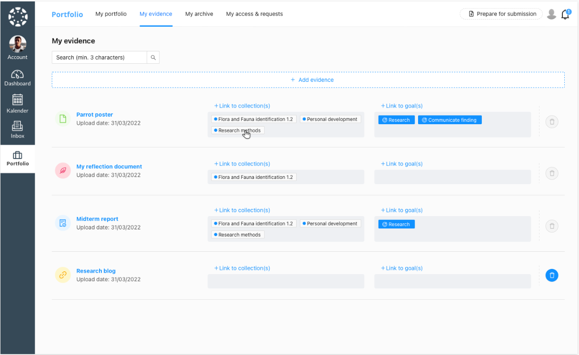

Image 2.Existing designs of My Evidence Section.

Next step was to have extensive talks with the Product Owner (PO) and the lead UX designer for Portflow. I shared their ideas and planned requirements, they shared their ideas and suggestions in return. The agreement was made to make 3 first designs with focus on using a ‘smarter’ list, using cards and using a file map. Several sketches were drawn on paper in different approaches before becoming a digital wireframe on Figma that was presented to PO and UX

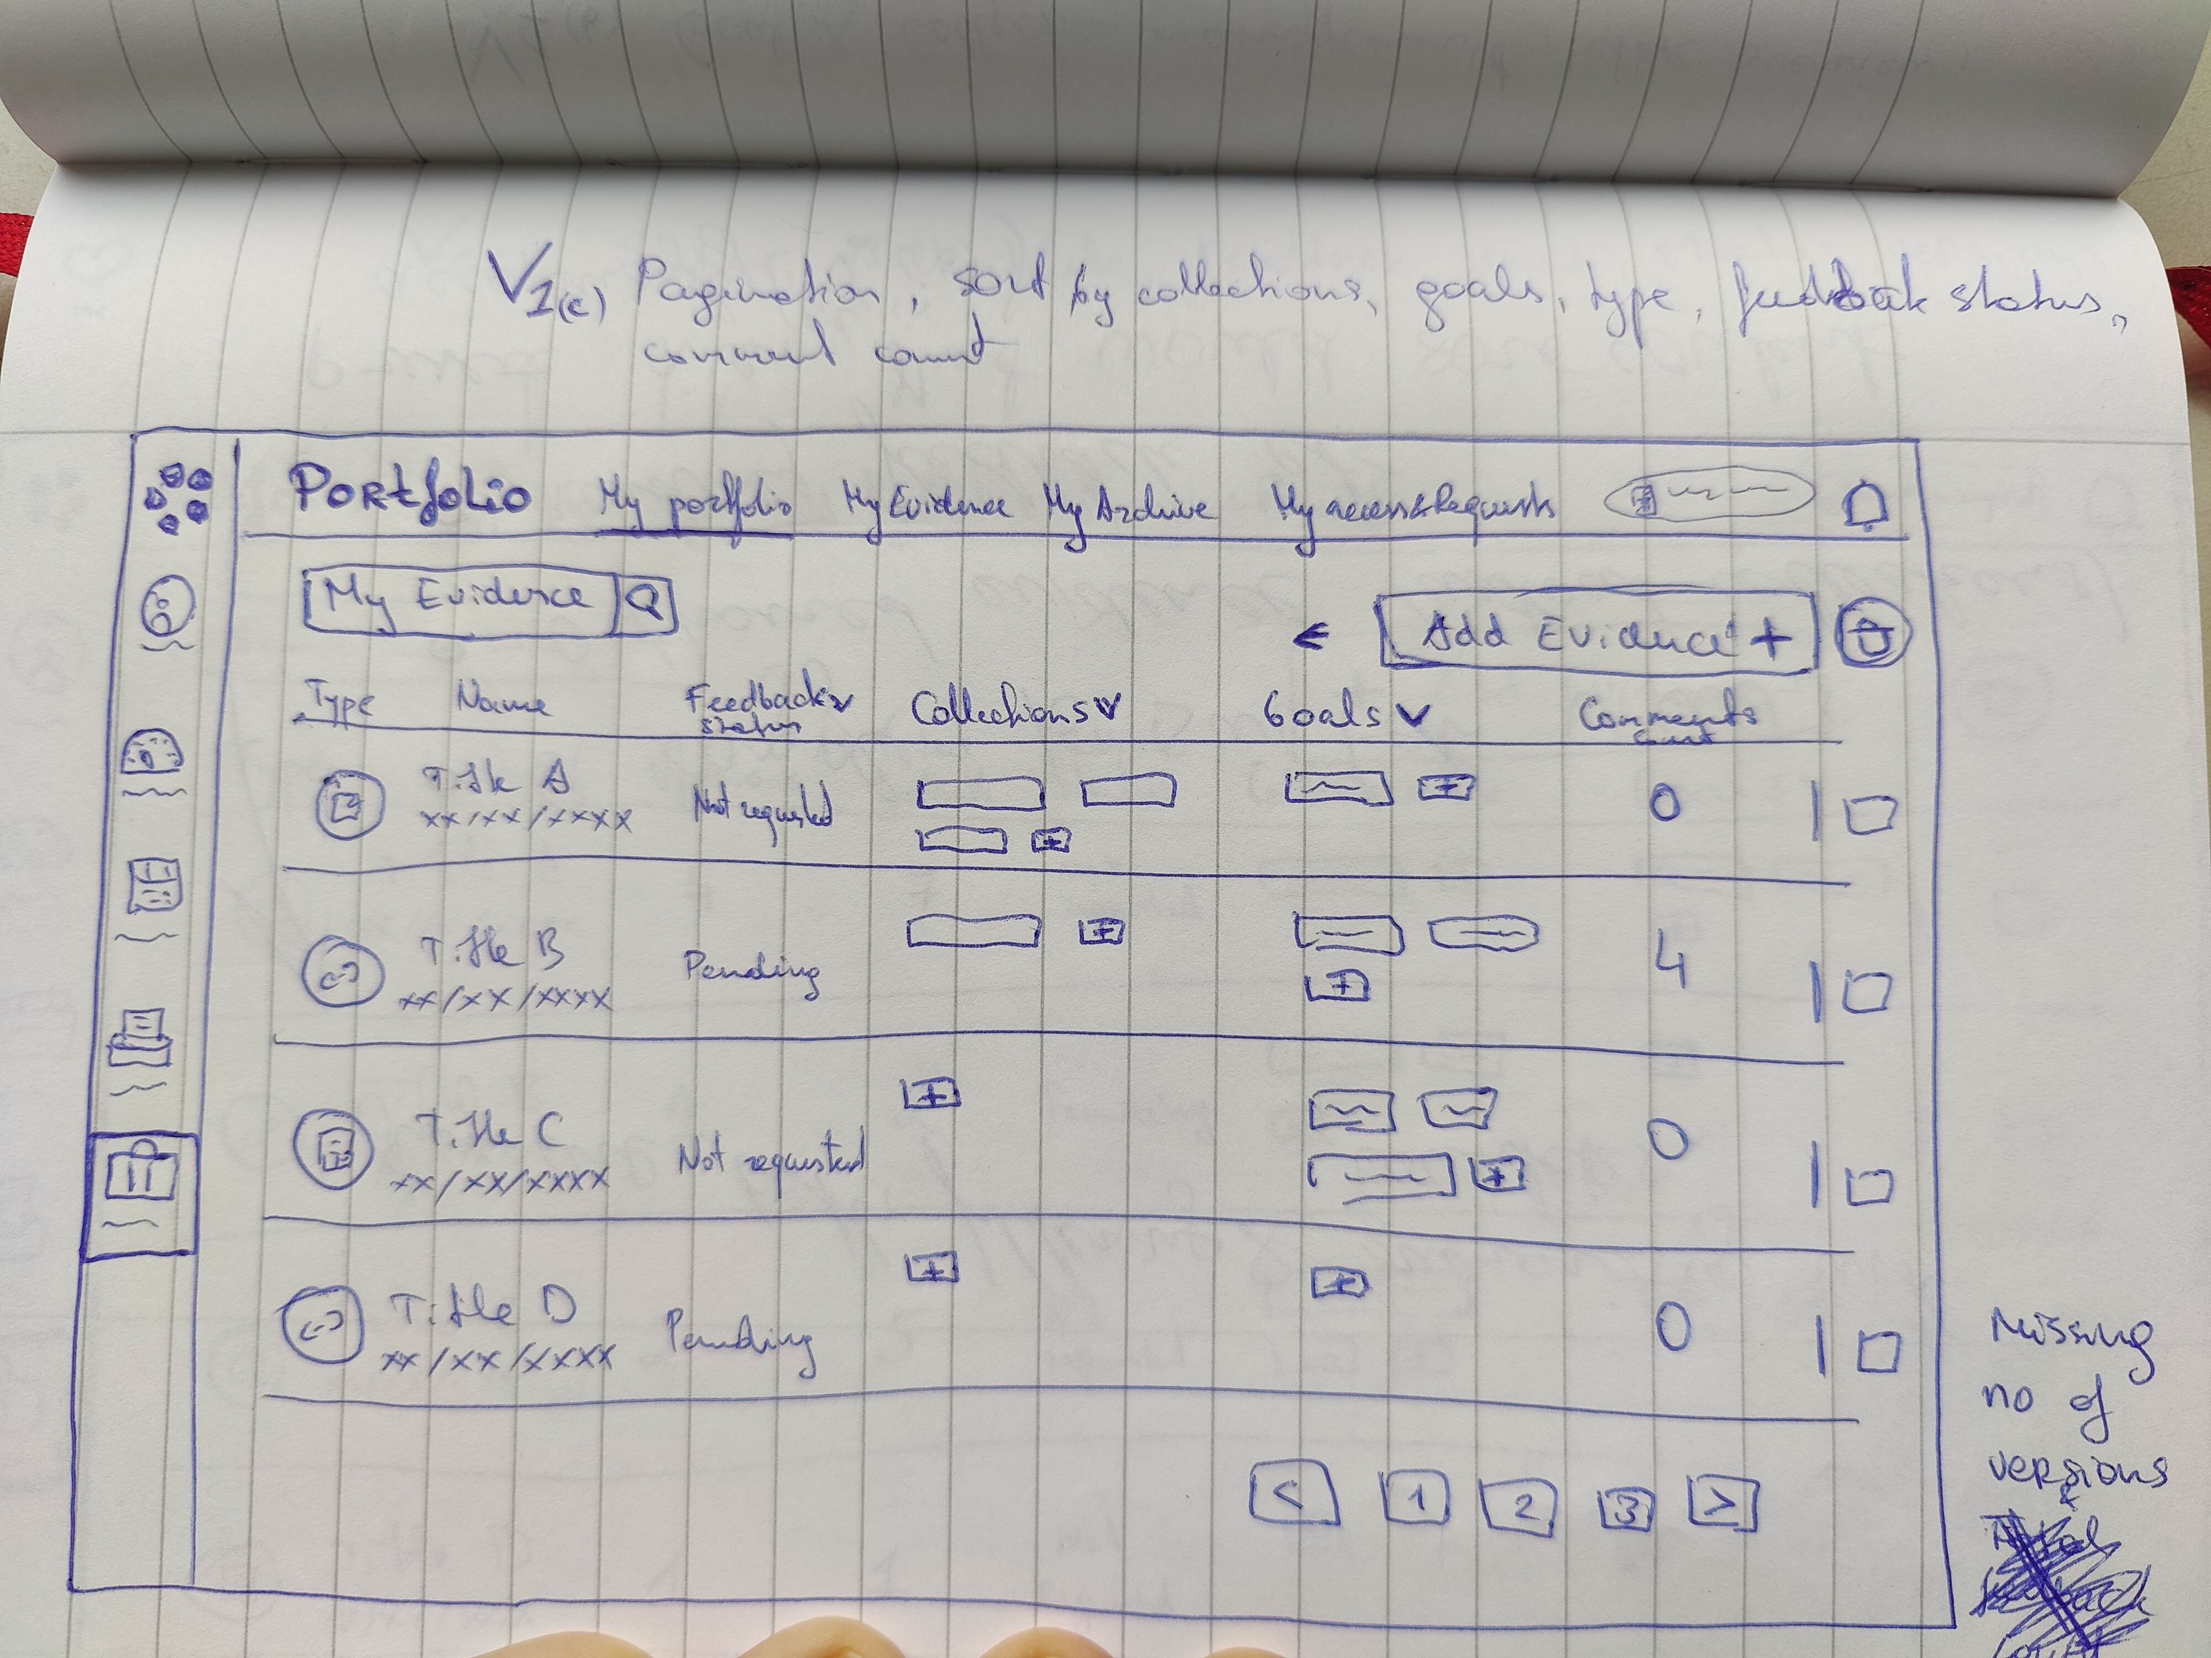

Image 3. One of the initial sketches of my design.

designer for additional feedback. The steps were repeated over several iterations taking the received feedback and advice into account until the right design was created. It was then pitched

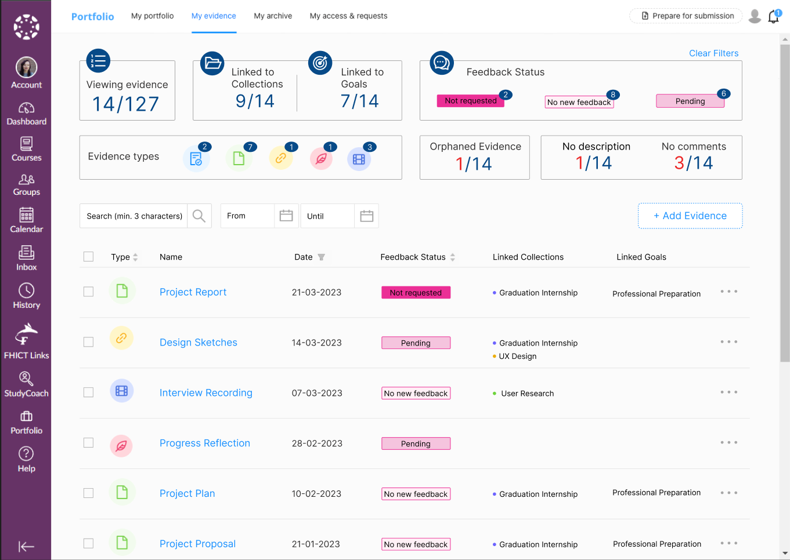

Image 4. The design wireframe that was pitched to the stakeholders to begin the development.

to the stakeholders and approved. Thus, concluding the design phase for now. Though, some modifications may still occur during the implementation phase. For information about design process and inspiration can be found in Requirements and Designing document as well as [Design Document](https://github.com/EditaAnomaly/S8-GI-Drieam/tree/main/2.%20Design). The feedback received is stored in the [Manage](https://github.com/EditaAnomaly/S8-GI-Drieam/tree/main/5.%20Manage) folder of the repository.

4.3 The Realization

The Development and deployment phase is the longest part of the internship. I got a chance to implement my ideas and over the course of internship the assignment even grew in its priority. Due to ongoing tenders with various universities and schools the My Evidence page became a dealbreaker feature.

Once the designs were approved, a refinement session was organized with both mentors to help split it into smaller tasks that would be more manageable for a beginner developer (in Ruby and React Typescript). Zenhub integration with GitHub was used to manage the tickets and I made my own epics and issues. First few sprints I did a lot of *Peer Programming* to help learn the basics. Later *Refinements* and issues were mostly led and initiated by me. Each ticket is reviewed by another developer, this is a common practice within the company.

Overall, the development was gradual, starting from basics and adding complexity as it progressed. Every few sprint the features were refined, and a set of new tickets were created in

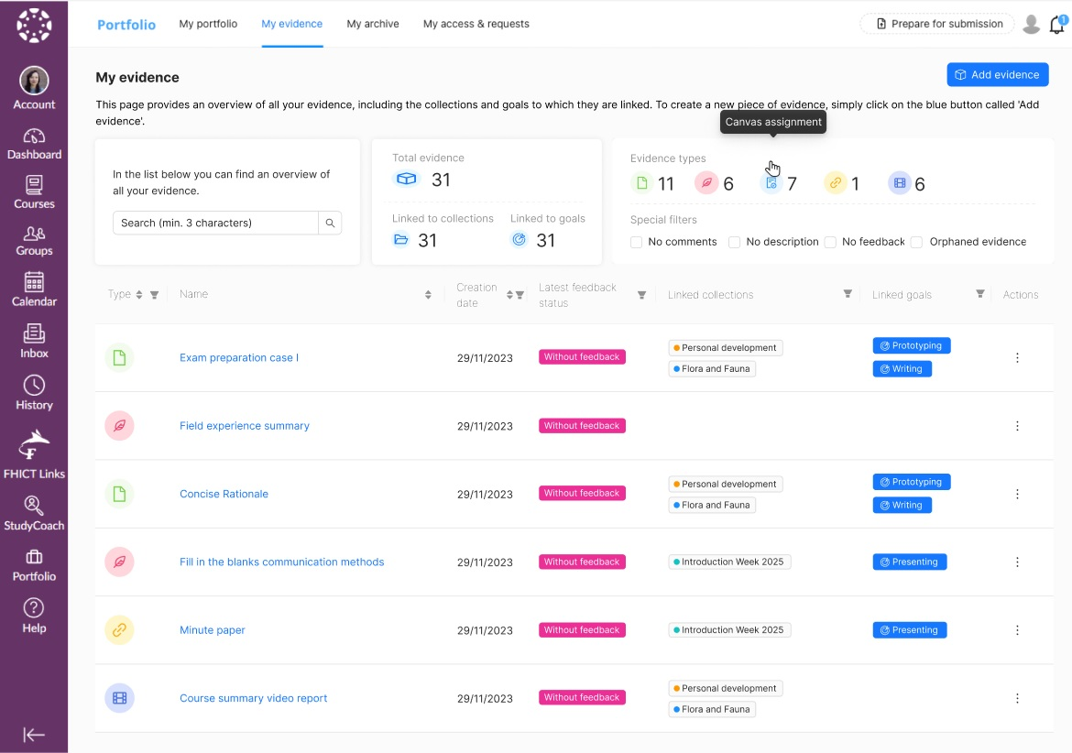

Image 5. The last design wireframe used in usability testing.

communication with Scrum Master, PO and mentors. Since, the design was also still getting improved (especially, the dashboard part) the quick adjustment was necessary. Last but not least, I did some practice courses of Ruby, Ruby on Rails and React frameworks, TypeScript and JavaScript during the whole internship to practice their skills too.

# Chapter 5: Conclusions and Recommendations

5.1 The Advice

The final design version consists of two parts: the table and the dashboard. The table is a big upgrade to the current Evidence list. It provides all the same overview and more with goal tags and explanatory tooltips with the added management features such as sorting and filtering. The format is familiar to the user, but with clear separation of information into columns. This is the part I implemented, and it will be released to production. The second part – the dashboard is what I recommend for the company to still implement. It add more visual overview and has “actionable” filters that help students to quicker locate evidence that needs attention.

In order, to verify my designs I performed tests with actual users of Portflow. The Test Plan, Recordings and Raw Results can be found in the

Talk about how it is better now and how could it be further improved.

More features, more control for the student (in-line with student-driven vision of the company)

A better overview from a main page, great sorting and filtering, clear and even functional statistics.

## 5.2 The Management

Describe and reflect on how I planned and managed the project on my own. What could I have done differently (better?).

Product Owner and UX designer are ones that constantly interact with the current and potential clients and end users, thus meeting their expectations was a priority. At the same time, I felt an obligation to help improve the evidence management for my fellow students. It was an honest effort.

Personal Reflection

Management >> reflect on how I handled the project and work, how I grew as a professional (knowledge and skills) as well as personally (traits and experience). Mention personal challenges and how I overcame them. I love the fact that what I am creating will be used by other students and educators. It is very inspiring.

References

Crawshaw, F. V. (2021, March 24). *Enterprise Filtering: UX Pattern Analysis*. Retrieved from Pencil and Paper: https://pencilandpaper.io/articles/ux-pattern-analysis-enterprise-filtering/

Daley, S. (2022, August 8). *Edtech 101*. Retrieved from Built In: https://builtin.com/edtech

Das, S. (2022, August 11). *Learning Tools Interoperability: The Future Of The LMS*. Retrieved from eLearning Industry: https://elearningindustry.com/learning-tools-interoperability-the-future-of-the-lms

Design Council. (2019, May 17). *Framework for Innovation: Design Council's evolved Double Diamond*. Retrieved from Design Council: https://www.designcouncil.org.uk/our-work/skills-learning/tools-frameworks/framework-for-innovation-design-councils-evolved-double-diamond/